LAB 25

**Lab1:** Suppose you are a teacher, and you want to analyze the exam scores of your students in a particular subject. You have recorded the scores of your students for a recent exam, and you want to represent this data using a Pandas Series.

**Input:** students = ['Alice', 'Bob', 'Charlie', 'David', 'Eve', 'Frank', 'Grace', 'Hannah', 'Ivy', 'Jack'] exam_scores = [92, 88, 76, 94, 82, 90, 85, 89, 78, 91]

**Output:**

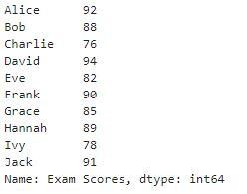

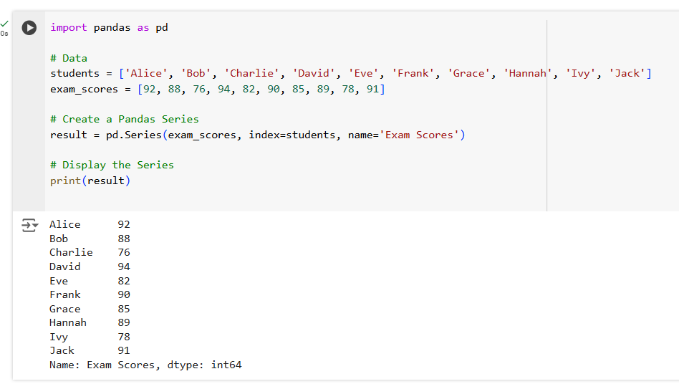

**Lab2:** Suppose you want to track and analyze your household expenses for a month. You have recorded the expenses for various categories, such as groceries, utilities, rent, transportation, and entertainment. You can represent this expense data using a Pandas Series.

**Input:**

# Expense categories

categories = ['Groceries', 'Utilities', 'Rent', 'Transportation', 'Entertainment']

# Monthly expense data (example data in USD) expenses = [500, 200, 1200, 300, 150]

**Output:**

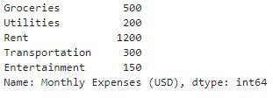

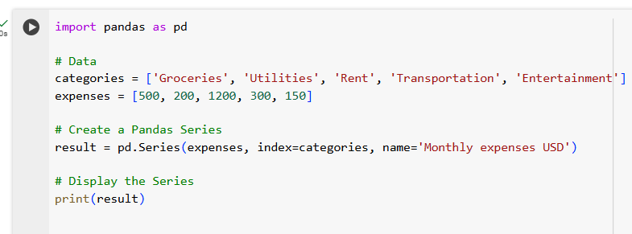

**Lab3:** Suppose you want to track and analyze the monthly energy consumption in your home. You have recorded the monthly energy usage for electricity and gas over a year, and you want to represent this data using Pandas Series.

**Input:**

# Months in a year

months = ['January', 'February', 'March', 'April', 'May', 'June', 'July', 'August', 'September', 'October', 'November', 'December']

# Monthly energy consumption data (example data in kilowatt-hours for electricity and therms for gas) electricity_usage = [350, 320, 310, 330, 340, 370, 380, 360, 350, 330, 320, 330] gas_usage = [20, 18, 16, 15, 12, 10, 8, 9, 12, 15, 17, 19]

**Output:**

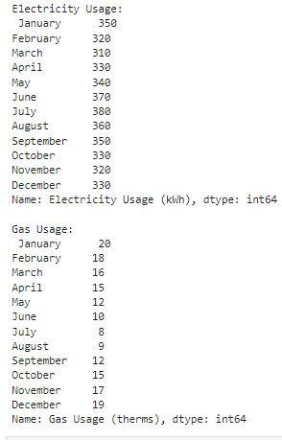

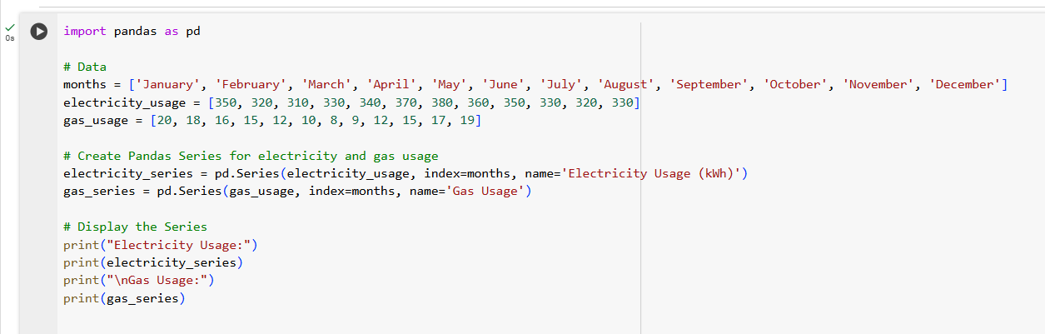

**Lab4:**Suppose you are managing a website and want to analyze the monthly revenue generated from advertising. You have recorded the monthly revenue for the past year, and you want to represent this data using a Pandas Series.

**Input:**

# Months in a year

months = ['January', 'February', 'March', 'April', 'May', 'June', 'July', 'August', 'September', 'October', 'November', 'December']

# Monthly advertising revenue data (example data in USD)

revenue = [5000, 5200, 4800, 5400, 5600, 5800, 6100, 5900, 6200, 6500, 7000, 6900]

**Output:**

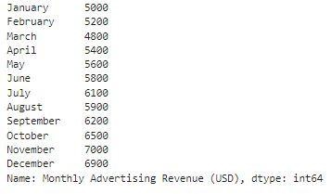

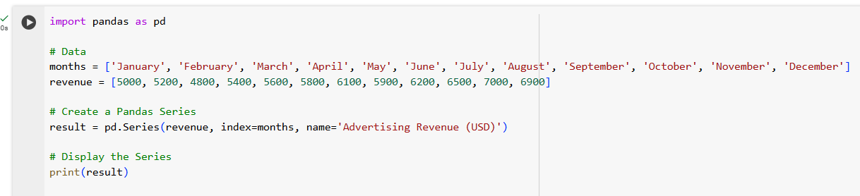

**Using ChatGPT generate the python code to solve the same problem** Hi! I have two columns with some dummy value. I want to create a line plot of the opening, closing stock prices of SBI between two specific dates using a pandas plot.Can you generate a complete code for me?

After generating the code using chatgpt, run the code, display the output and give your conclusion.

**ChatGPT Exercise**

**Using ChatGPT generate the python code to solve the same problem**

**Scenario: Analyzing Stock Prices**

Suppose you are an investor interested in analyzing the stock prices of a particular company over a year. You have collected daily closing prices for that company's stock, and you want to perform some analysis like Calculate the average daily return,Find the date with the highest closing price and also generate a line chart using Pandas Series.

Further, you need to get some inference out of the chart.

Create a ChatGPT prompt to generate the code for this scenario. Based on the code generated, ask ChatGPT to give the conclusion/inference.

Note. You can provide the data to ChatGPT in the form of a list or dictionary or ask it to use sample data.

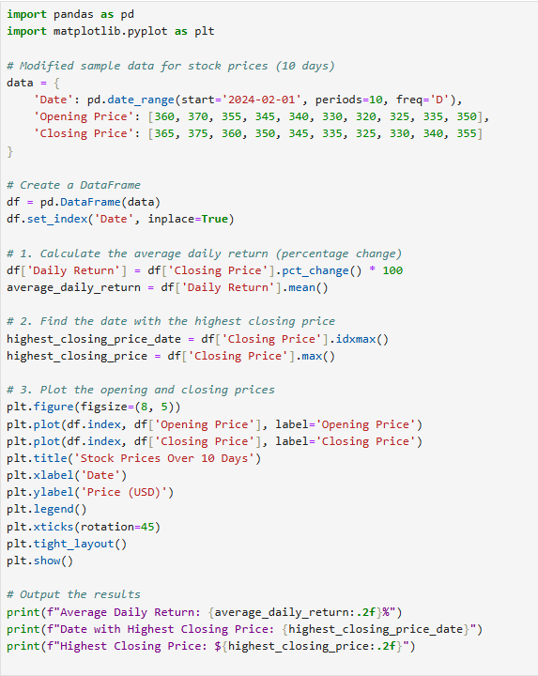

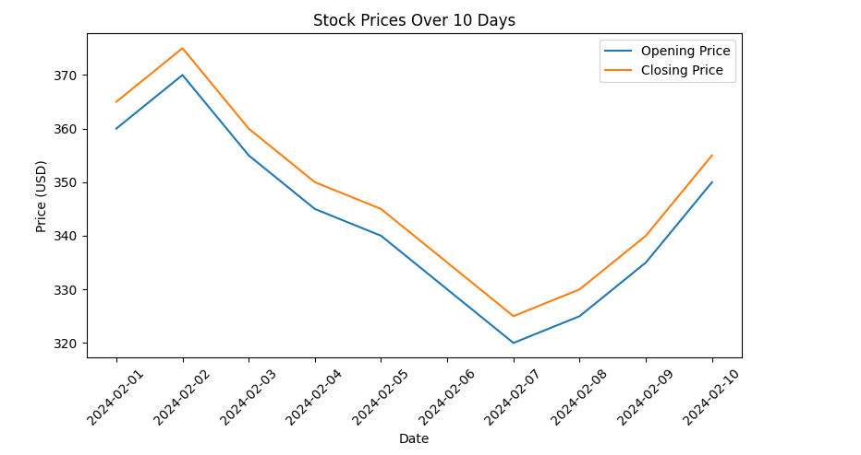

**Conclusion from the Plot:**

📈 **Feb 1 - Feb 2:** Stock prices increased, reaching the highest point on **Feb 2**.

📉 **Feb 3 - Feb 7:** Continuous decline, hitting the lowest price on **Feb 7**.

🔄 **Feb 8 - Feb 10:** Prices started recovering, indicating a possible uptrend.

⚖️ **Key Insight:** A short-term **downtrend followed by a bullish reversal**.